**Singleton Pattern**

Method-1 using Lazy initialization

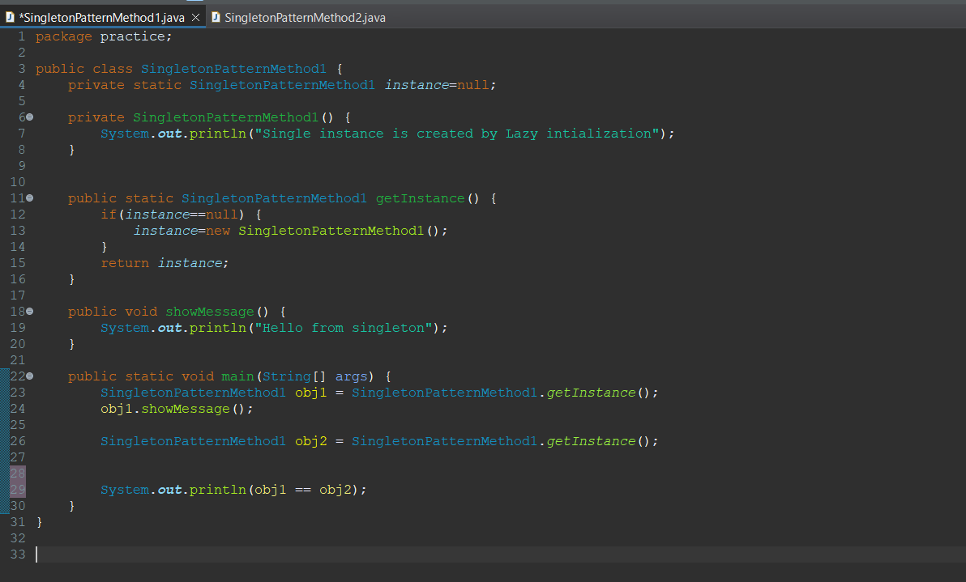

Output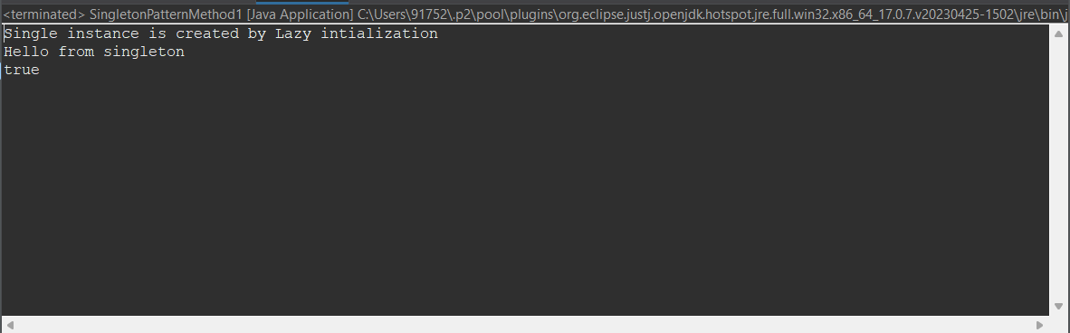

Method-2- by using Eager Initialization

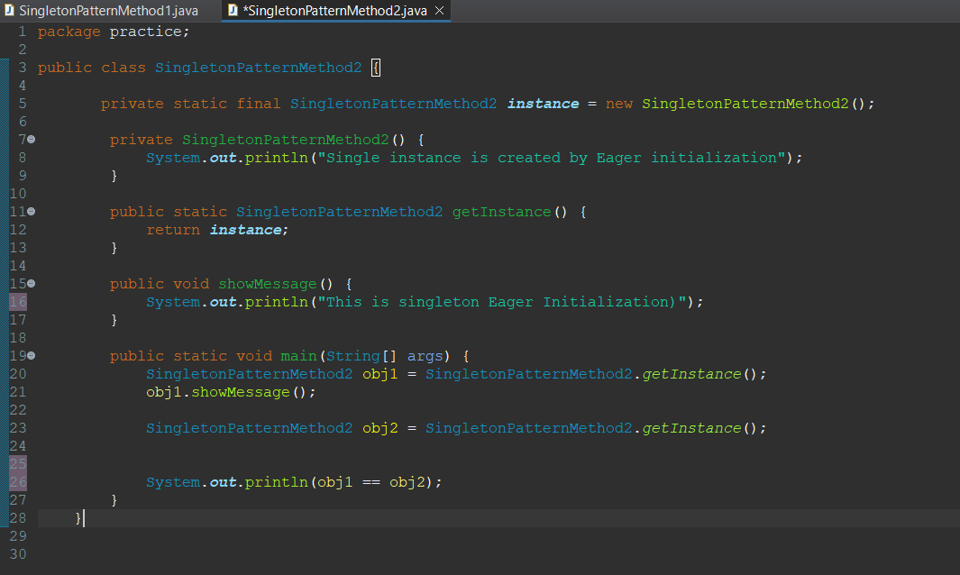

Output

